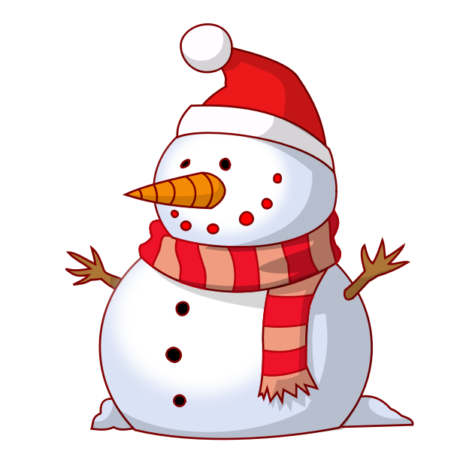 **December**  

| **Sunday** | **Monday** | **Tuesday** | **Wednesday** | **Thursday** | **Friday** | **Saturday** |
| --- | --- | --- | --- | --- | --- | --- |
|  |  |  |  |  | ***1***  ***MP 1 Ends*** | ***2*** |
| ***3*** | ***4***  ***MP 2 Begins***  ***7pm- HSA @CO*** | ***5***  ***12:48 Dismissal*** | ***6*** | ***7***  ***Picture Day Make-Ups*** | ***8***  ***Spiritwear*** | ***9*** |
| ***10*** | ***11*** | ***12*** | ***13***  ***12:48 Dismissal*** | ***14*** | ***15***  ***Report Cards***  ***7 -8:30pm-HSA Winter Wonderland*** | ***16*** |
| ***17*** | ***18***  ***Winter Spirit Week***  ***Wear White Like Snow Day*** | ***19***  ***Winter Spirit Week***  ***Fun Flannel Day*** | ***20***  ***Winter Spirit Week***  ***Cozy Sock Day*** | ***21***  ***Winter Spirit Week***  ***Sweater Weather Day*** | ***22***  ***12:48 Dismissal***  ***Winter Spirit Week***  ***Pajama Party Day*** | ***23*** |
| ***24*** | ***25***  ***School Closed- Winter Recess*** | ***26***  ***School Closed- Winter Recess*** | ***27***  ***School Closed- Winter Recess*** | ***28***  ***School Closed-***  ***Winter Recess*** | ***29***  ***School Closed- Winter Recess*** | ***30*** |